ERROR FILE

G. REENA SRI

22MID0009

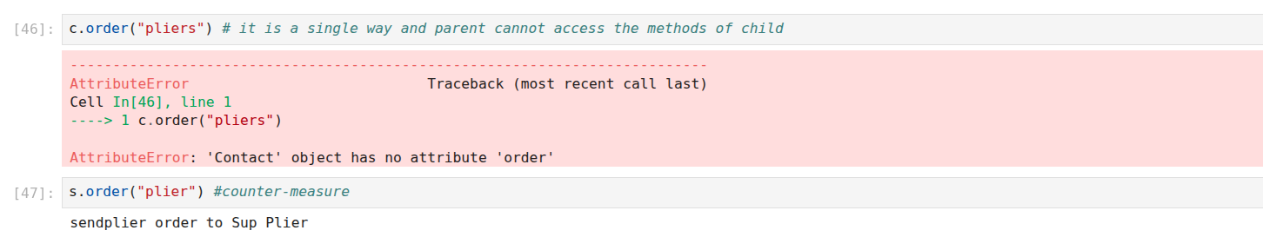

##understanding the uni-directional property of inhert classes